SQL & DBMS Practical Work
Name: Jajula Gnana Deepak ID:2300030263 Subject: Database Management System (DBMS) Tools Used: MySQL Workbench

Task 1 — Create College Database and Students Table Objective
Create a database, create a Students table, insert 5 student records, and display the records. CREATE DATABASE CollegeDB;
USE CollegeDB;

CREATE TABLE Students( StudentID INT PRIMARY KEY,
StudentName VARCHAR(100) NOT NULL, Age INT UNSIGNED,
Email VARCHAR(100), Course VARCHAR(100)
);
INSERT INTO Students VALUES
(1,'Rahul',20,'r@gmail.com','CSE'),
(2,'Priya',21,'p@gmail.com','ECE'),
(3,'Arjun',20,'a@gmail.com','CSE'),
(4,'Sneha',22,'s@gmail.com','EEE'),
(5,'Kiran',21,'k@gmail.com','MECH'); SELECT * FROM Students;
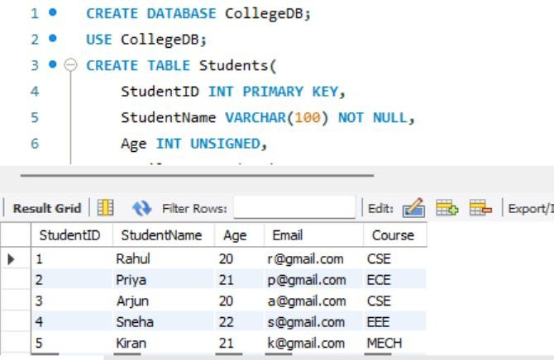

What I Did
- Created the CollegeDB database.
- Selected the database using USE.
- Created the Students table.
- Applied PRIMARY KEY, NOT NULL, and UNSIGNED constraints.
- Inserted 5 student records.
- Displayed all student records using SELECT.

Task 2 — Create Library Database Objective
Create a library database containing Books, Members, and Borrowing tables and establish relationships using foreign keys.

CREATE DATABASE LibraryDB;
USE LibraryDB;
CREATE TABLE Books(
bookid INT PRIMARY KEY,
title VARCHAR(100) NOT NULL,
author VARCHAR(100), publishyear INT,
category VARCHAR(100)
);
CREATE TABLE Members(
memberid INT PRIMARY KEY,
membername VARCHAR(100) NOT NULL, email VARCHAR(100),
phone VARCHAR(15)
);
CREATE TABLE Borrowing(
borrowid INT PRIMARY KEY, bookid INT,

memberid INT, borrowdate DATE, returndate DATE,
FOREIGN KEY (bookid) REFERENCES Books(bookid),
FOREIGN KEY (memberid) REFERENCES Members(memberid)
);
SHOW TABLES;
SELECT * FROM Books;
SELECT * FROM Members;
SELECT * FROM Borrowing;
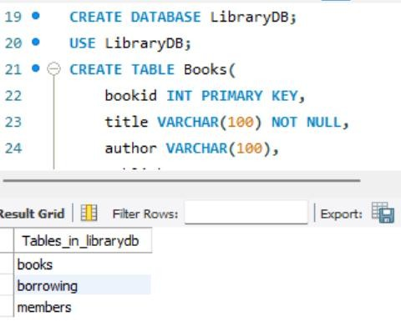

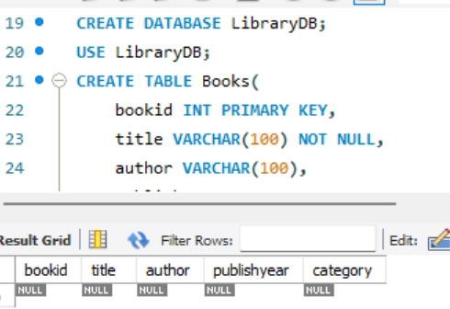
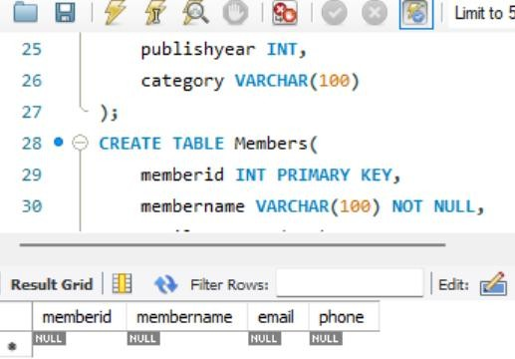

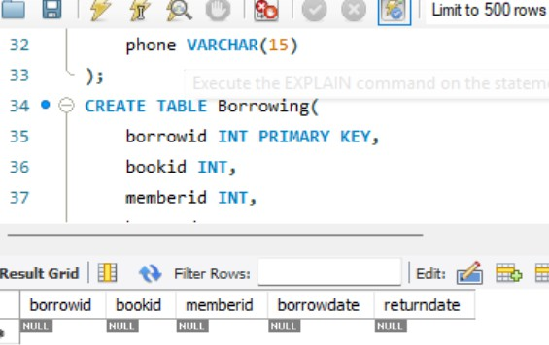

What I Did
- Created the LibraryDB database.
- Created the Books table to store book details.
- Created the Members table to store member details.
- Created the Borrowing table to store borrowing transactions.
- Used PRIMARY KEY for unique identification.
- Used FOREIGN KEY to establish relationships between tables.
- Used SHOW TABLES to display the tables.
- Used SELECT to view the table contents.

Task 3 — Create Hospital Database Objective
Create a HospitalDB database, create a Patients table, insert patient records, and display them. CREATE DATABASE HospitalDB;
USE HospitalDB;

CREATE TABLE Patients( patientid INT PRIMARY KEY,
patientname VARCHAR(100) NOT NULL, age INT UNSIGNED,
gender VARCHAR(15),
healthissue VARCHAR(100)
);

INSERT INTO Patients VALUES (1,'Rahul',25,'M','Fever'),

(2,'Priya',30,'F','BP'),
(3,'Arjun',22,'M','Cold'),
(4,'Sneha',28,'F','Asthma'),
(5,'Kiran',35,'M','BP');

SELECT * FROM Patients;
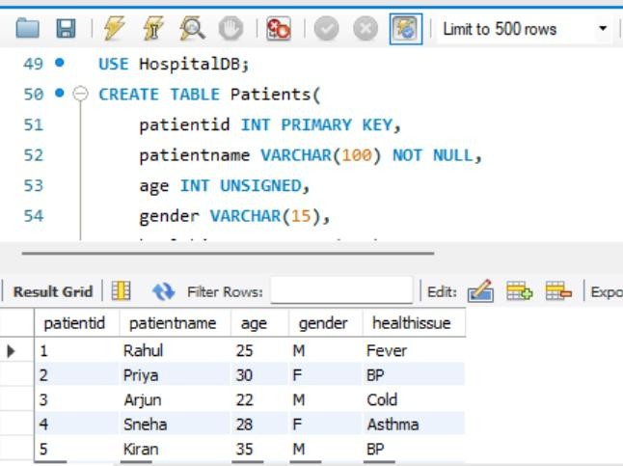

Task 4 — Check Current Database Objective
Find the currently selected database. SELECT DATABASE();
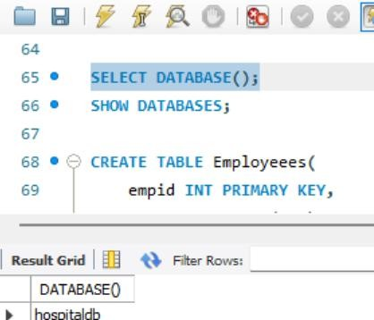

What I Did
- Used SELECT DATABASE() to identify the currently selected database.

Task 5 — Create Employee Table Objective
Create an employee table with appropriate data types and constraints. CREATE TABLE Employeees(
empid INT PRIMARY KEY,
empname VARCHAR(100) NOT NULL, email VARCHAR(100),
salary DECIMAL(10,2), age INT UNSIGNED
);
SELECT * FROM Employeees;
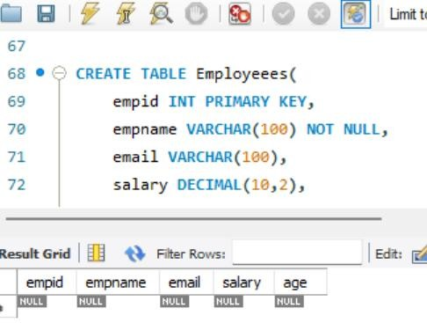

What I Did
- Created the Employeees table.
- Used PRIMARY KEY for employee identification.
- Used NOT NULL for employee name.
- Used DECIMAL(10,2) for salary.
- Used UNSIGNED for age.
- Displayed the table contents.

Task 6 — College Student Management System

Objective
Create a student management database with constraints and perform filtering and data-integrity tests. CREATE DATABASE CollegeManagement;
USE CollegeManagement;

CREATE TABLE Students(
studentid INT UNSIGNED PRIMARY KEY,
studentname VARCHAR(100) NOT NULL, email VARCHAR(100) UNIQUE NOT NULL, phone VARCHAR(15) UNIQUE,
age INT UNSIGNED NOT NULL, dept VARCHAR(50) NOT NULL, year INT UNSIGNED NOT NULL, cgpa DECIMAL(3,2) UNSIGNED
);
INSERT INTO Students VALUES
(1,'Rahul Sharma','rahul@gmail.com','9876543210', 20, 'CSE', 2, 8.50),
(2,'Priya Reddy','priya@gmail.com','9876543211', 21, 'ECE', 3, 9.10),
(3,'Arjun Kumar','arjun@gmail.com','9876543212', 19, 'CSE', 1, 7.80),
(4,'Sneha Rao','sneha@gmail.com','9876543213', 22, 'EEE', 4, 8.90),
(5,'Kiran Patel','kiran@gmail.com','9876543214', 21, 'MECH', 3, 7.50),
(6,'Ananya Das','ananya@gmail.com','9876543215', 20, 'CSE', 2, 9.20),
(7,'Vikram Singh','vikram@gmail.com','9876543216', 23, 'CIVIL', 4, 8.10), (8,'Neha Gupta','neha@gmail.com','9876543217', 19, 'ECE',1,8.70),
(9,'Rohan Verma','rohan@gmail.com','9876543218', 22, 'CSE',4, 9.00),
(10,'Meena Joshi','meena@gmail.com','9876543219',20,'IT',2,7.90);

SELECT * FROM Students;

SELECT *
FROM Students WHERE dept='CSE';

SELECT *
FROM Students WHERE cgpa>8;

SELECT *
FROM Students WHERE age>20;

INSERT INTO Students VALUES
(1, 'T', 't@gmail.com', '9876500000', 20, 'CSE', 2, 8.00);

INSERT INTO Students VALUES
(11, 'Test Student', 'rahul@gmail.com', '9876500011', 21, 'CSE', 3, 8.20);

INSERT INTO Students VALUES
(12, NULL, 'test12@gmail.com', '9876500012', 20, 'CSE', 2, 8.00);

INSERT INTO Students VALUES
(13, 'Test Student', 'test13@gmail.com', '9876500013', -20, 'CSE', 2, 8.00);

ALTER TABLE Students
ADD address VARCHAR(200);
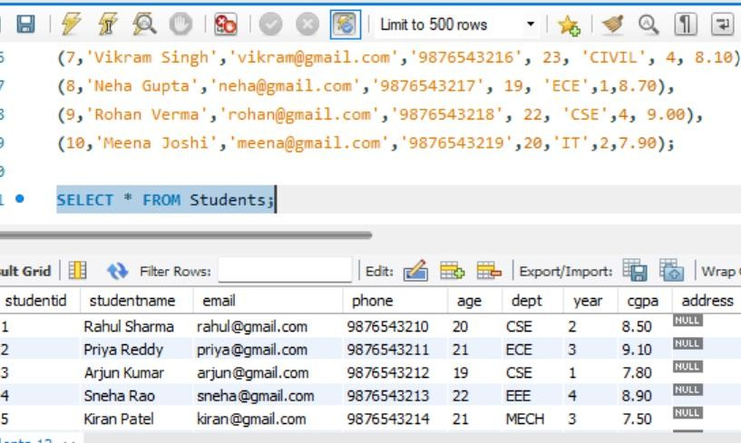

What I Did
- Displayed students from the CSE department using the WHERE clause.
- Displayed students with CGPA greater than 8.

- Displayed students whose age is above 20.
- Tested the PRIMARY KEY constraint by inserting a duplicate Student ID.
- Tested the UNIQUE constraint by inserting a duplicate Email.
- Tested the NOT NULL constraint by inserting a NULL student name.
- Tested the UNSIGNED constraint by inserting a negative age.
- Modified the Students table by adding a new Address column using ALTER TABLE. Task 7 — Normalization

Objective
Separate student and department information into related tables to reduce data redundancy. CREATE DATABASE StudentDB;
USE StudentDB;

CREATE TABLE Departments(
Department_ID INT PRIMARY KEY, Department VARCHAR(50),
HOD VARCHAR(100)
);

CREATE TABLE Students( Student_ID INT PRIMARY KEY,
Student_Name VARCHAR(100) NOT NULL, Department_ID INT,
FOREIGN KEY (Department_ID)
REFERENCES Departments(Department_ID)
);
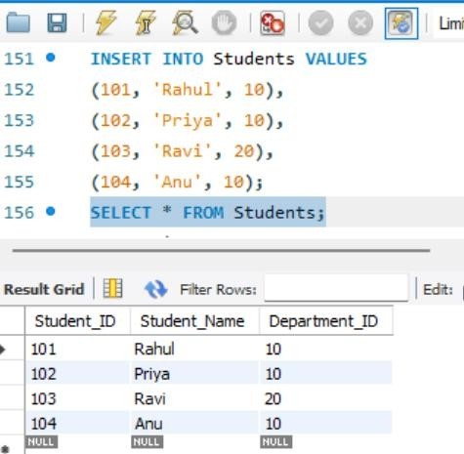

What I Did
- Created separate Students and Departments tables.
- Used Department_ID to connect the two tables.
- Added a foreign key relationship.
- Reduced repeated department and HOD information. Insert Normalized Data
INSERT INTO Departments VALUES (10, 'CSE', 'Dr. Kumar'),
(20, 'ECE', 'Dr. Sharma');

INSERT INTO Students VALUES (101, 'Rahul', 10),
(102, 'Priya', 10),
(103, 'Ravi', 20),
(104, 'Anu', 10);

What I Did
Inserted department information separately and connected students to departments using Department_ID.
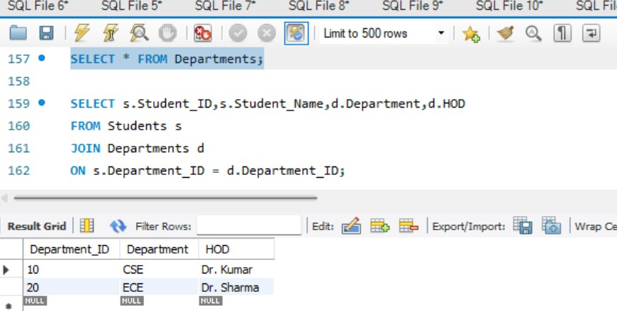
Task 8 — INNER JOIN,LEFT JOIN, RIGHT JOIN
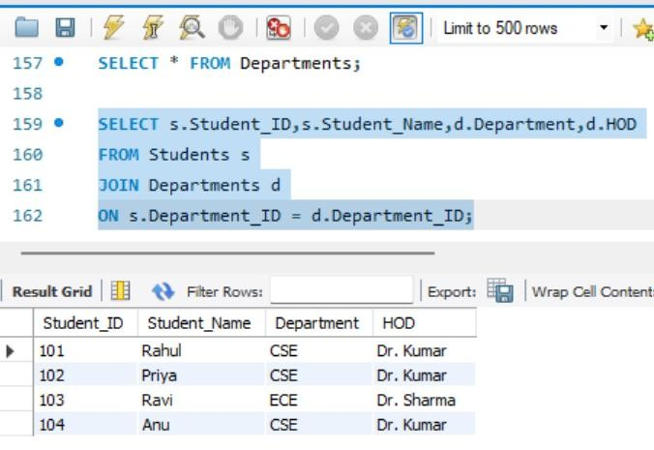

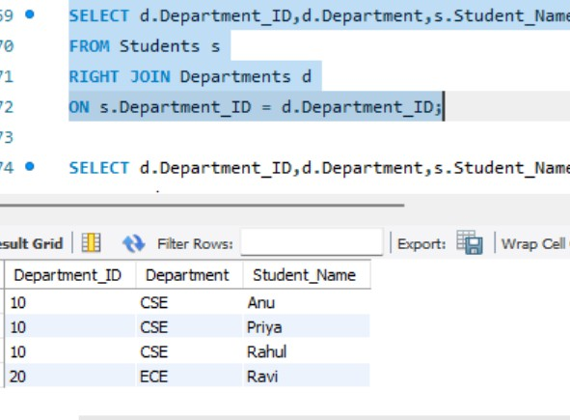
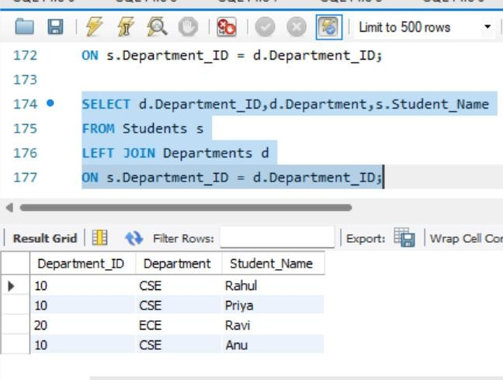

Task 9 — FULL OUTER JOIN Using UNION

Objective
Display all matching and non-matching records from both tables. SELECT s.Student_ID,s.Student_Name,d.Department
FROM Students s
LEFT JOIN Departments d
ON s.Department_ID = d.Department_ID UNION
SELECT s.Student_ID,s.Student_Name,d.Department FROM Students s
RIGHT JOIN Departments d
ON s.Department_ID = d.Department_ID;

What I Did
- Used LEFT JOIN to get all students.
- Used RIGHT JOIN to get all departments.
- Used UNION to combine both results.
- Implemented the concept of a FULL OUTER JOIN in MySQL.

